**Beginner's Guide to Mobile Development**

**Introduction to Mobile Development: By DrewGallowayDev22**

Mobile development is the process of creating software applications that run on mobile devices such as smartphones and tablets. This guide will give you an overview of mobile development, including the tools, languages, and frameworks you can use, before diving into a practical project: creating a simplebrowser app using Apache Cordova. It’s simple since Cordova helps you create applications on HTML, CSS & JavaScript.

**1. Types of Mobile Development**

**Native Development**

* **Definition**: Building applications specifically for one platform (iOS or Android).
* **Pros**:
  + High performance
  + Full access to device features (camera, GPS, etc.)
* **Cons**:
  + Requires separate codebases for each platform, leading to higher development costs.

**Cross-Platform Development**

* **Definition**: Developing applications that work on multiple platforms using a single codebase.
* **Popular Frameworks**:
  + **React Native**: Uses JavaScript and React to build native apps.
  + **Flutter**: Uses Dart and provides a rich set of pre-designed widgets.
  + **Apache Cordova**: Uses web technologies (HTML, CSS, JavaScript) to create mobile apps.

**2. Programming Languages**

* **Swift**: The primary language for iOS development.
* **Kotlin**: The preferred language for Android development.
* **Java**: An older language still widely used for Android apps.
* **JavaScript**: Essential for cross-platform frameworks like React Native and Cordova.
* **Dart**: The programming language used with Flutter.

**3. Development Tools**

* **Integrated Development Environments (IDEs)**:
  + **Android Studio**: The official IDE for Android development.
    - Features:
      * Code editor with syntax highlighting and code completion.
      * Built-in emulator for testing.
      * Tools for debugging and performance analysis.
  + **Xcode**: The official IDE for iOS development.
* **Other Useful Tools**:
  + **Visual Studio Code**: A lightweight code editor with extensions for Cordova and other frameworks.
  + **Postman**: Useful for testing APIs.
  + **Figma** or **Adobe XD**: For designing UI/UX.

**4. Overview of Mobile Development Frameworks**

**Native Frameworks**

* **iOS**:
  + **UIKit**: Framework for building iOS user interfaces.
  + **SwiftUI**: A newer declarative framework for UI design.
* **Android**:
  + **Jetpack**: A set of libraries to help with Android app development.

**Cross-Platform Frameworks**

* **React Native**: Allows you to build native apps using JavaScript and React.
* **Flutter**: A UI toolkit for building natively compiled applications for mobile from a single codebase.
* **Apache Cordova**: Enables you to build mobile applications using web technologies (HTML, CSS, JavaScript).

**Main part: Creating Application On Cordova**

Summary of Commands

1. Install Node.js: Download from the official site.
2. Install Cordova: npm install -g cordova
3. Create Project: cordova create MyApp com.example.myapp MyApp
4. Navigate: cd MyApp
5. Add Platforms: cordova platform add android and cordova platform add ios
6. Install Plugins: cordova plugin add cordova-plugin-network-information and cordova plugin add cordova-sqlite-storage
7. Edit HTML/CSS/JS: Customize in www/.
8. Build: cordova build
9. Run: cordova run android or cordova run ios
10. Debugging: Use Chrome or Safari developer tools.
11. Prepare for Production: cordova build --release

**1. Creating a Simple Browser App with Cordova**

Now that you have an overview of mobile development, let's focus on building a simple Google Search Engine using Apache Cordova.

**Step-by-Step Guide**

**Step 1: Install Prerequisites**

1. **Install Node.js**: Download and install from [nodejs.org](https://nodejs.org).
2. **Install Cordova**: Open a terminal and run:

bash

**Copy**

***npm install -g cordova***

**Step 2: Create a New Cordova Project**

1. **Open Terminal** and create your project:

**bash**

**Copy**

***Cordova create SimpleBrowser com.drewgallowaydev.simplebrowser SimpleBrowser***

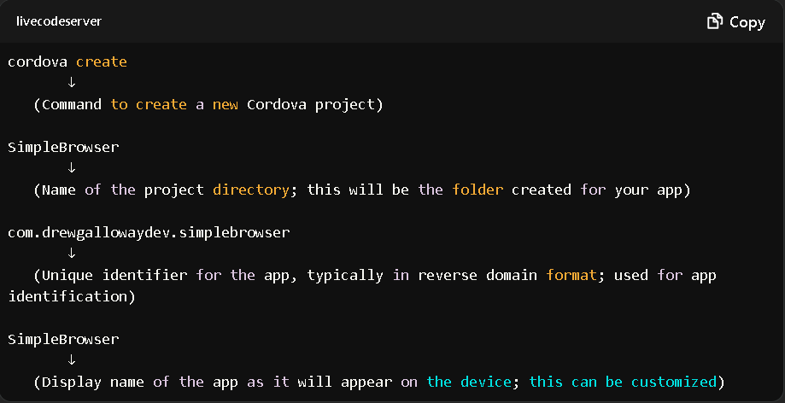

1. **Navigate to Project Directory**:

bash

Copy

***cd SimpleBrowser***

**Step 3: Add Platforms**

* For Android (ensure you have Android Studio installed):

**bash**

**Copy**

***cordova platform add android***

* For iOS (ensure you have Xcode installed):

***bash***

***Copy***

***cordova platform add ios***

**Step 4: Add HTML, CSS, and JavaScript**

1. **Open the www folder**: This is where your app’s front-end files are located.
2. **Edit index.html**:
3. **Create and edit css/styles.css file**:

}

**Step 5: Implementing Network Features**

To handle network requests and detect connectivity, you can use the Cordova Network Information plugin:

1. **Install the Network Information Plugin**:

***bash***

***Copy***

***cordova plugin add cordova-plugin-network-information***

1. **Update js/index.js to Check Network Status**:

You need to install the following Cordova plugins:

* **Network Information Plugin**: To check the network status.
* **SQLite Plugin**: To store data locally.

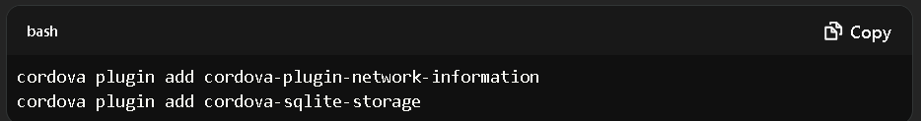

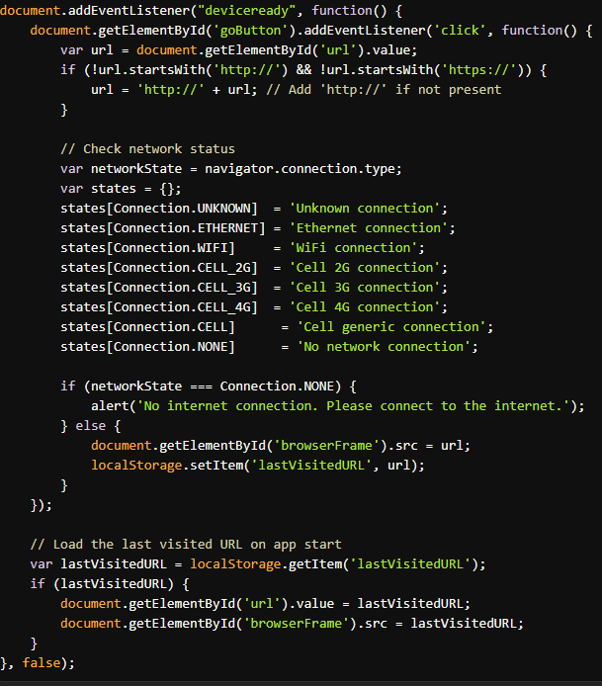

**Use SQLite for Offline Data Storage (optional)**

Here’s how to use the SQLite plugin to store data locally:

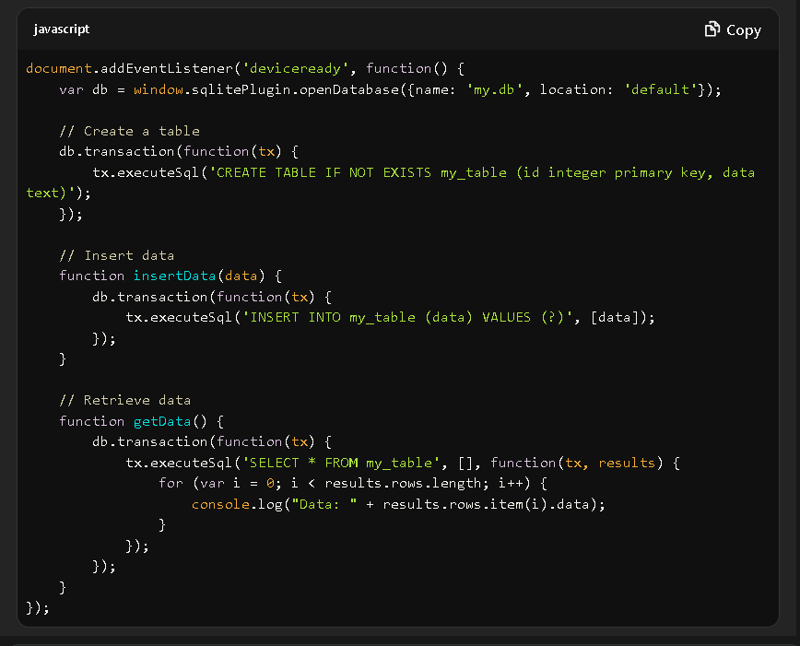

**Step 6: Build Your App**

* Run the following command to build your app:

***bash***

***Copy***

***cordova build android***

**Step 6: Deploy and Test Your App**

* ***For Android:***

***bash***

***Copy***

***cordova run android***

* ***For iOS:***

***bash***

***Copy***

***cordova run ios***

**6. Resources for Further Learning**

* **Documentation**:
  + [Cordova Documentation](https://cordova.apache.org/docs/en/latest/)
  + [Mozilla Developer Network (MDN)](https://developer.mozilla.org)
* **Online Courses**:
  + [Udemy](https://www.udemy.com)
  + Edx ,Coursera, Appcorda IOS
  + [Coursera](https://www.coursera.org)
* **Communities**:
  + [Stack Overflow](https://stackoverflow.com)
  + [Reddit - r/webdev](https://www.reddit.com/r/webdev/)
  + [Hacknations mobile development](https://hacksnation.com/?q=mobile%20development)